Marcin PIĄTKOWSKI
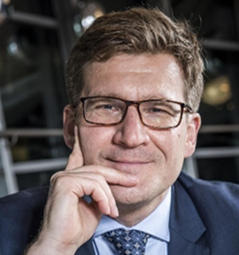
- Visiting professor, European Interdisciplinary Studies Department
Prof. Marcin PIĄTKOWSKI is a Professor of Economics at Kozminski University in Warsaw and a Lead Economist for South Asia at the Finance, Competitiveness, and Innovation Department of the World Bank in New Delhi. Before moving to India, he led the World Bank’s private sector development support for the governments of China, Vietnam, the Philippines, Mongolia, Ukraine, Latvia, Czechia, and Poland.
Prior to joining the World Bank, he was the Chief Economist and Managing Director of PKO BP, the largest bank in Central and Eastern Europe. He also worked as an economist in the European Department of the IMF and served as an Advisor to the IMF's Executive Director. He was an Advisor to Poland's Deputy Premier and Minister of Finance.
Prof. Piątkowski holds a Ph.D. and habilitation in Economics from Kozminski University and an M.A. in Finance and Banking, summa cum laude, from the Warsaw School of Economics. He was a visiting scholar at Harvard University, London Business School, and the OECD Development Center, and a visiting lecturer at Peking University’s Guanghua School of Management. He has delivered presentations at numerous universities worldwide, including Harvard, Stanford, Yale, Princeton, Dartmouth, and Berkeley, as well as international institutions like the IMF, OECD, AAIB, EBRD, and the World Bank. He has also led economic panels at the World Economic Forum in Davos.
Prof. Piątkowski has published extensively on economic development, innovation, and competitiveness. He authored the book “Europe’s Growth Champion: Insights from the Economic Rise of Poland,” published by Oxford University Press in 2018. The book has been reviewed by the Financial Times, endorsed by global leading economists, and awarded the “Best Book in Economics” prize in 2019 by the Polish Academy of Sciences and the “Best Book in Economic Education” prize in 2020 in a competition sponsored by the National Bank of Poland. A second edition of the book will be published in the fall of 2025. The Polish edition has become a bestseller in Poland, and Ukrainian and Chinese translations are forthcoming.
For more information, visit his personal website at www.marcinpiatkowski.com. You can also follow him on X at @mmpiatkowski and on LinkedIn at https://www.linkedin.com/in/marcinmpiatkowski/

